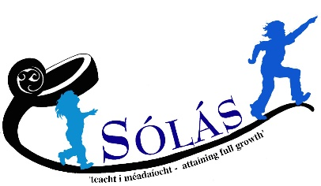
Charity No. NIC100114

Summer Scheme 2016 ~ Returning Volunteer Application

- Personal Details

Surname |  | Forenames: |  | Title:
Previous surnames: |  |  | Date of Birth:
Marital Status: Single |  |  | National Insurance Number:
Home Address:

Post Code:

Address for correspondence if different from above:

Contact details | Mobile number:  Email:

- Please detail dates you volunteered with Sólás on previous years:

*Please note that if you volunteered with Sólás more than two years ago you will be required to complete another AccessNI form.

- Please details changes to any of the following since your last application:
 | Details | Date | Outcome/ Pending?
Secondary Education / Professional Qualifications
Employment History
Training Courses / Skills
Medical History
(details of illnesses, operations or accidents resulting in absence from work or medical conditions that you suffer from e.g. diabetes, epilepsy)

Are you registered disabled? No

Relevant voluntary work experience in working with 4 – 12 year olds and children with special needs.
Any other relevant information

Disclosure of Conviction

This post will involve contact with children and young people. Spent convictions may be disclosed.

Have you ever been convicted of a criminal offence? No

If so please give brief details

What weeks are you available (tick all that apply)?

Mon 4th- Fri 8th July (insert √) | Mon 18th – Fri 22nd July (insert ) | Mon 1st - Fri 5th August (insert √) | Mon 8th - Fri 12th August (insert √)

**Sólás is committed to providing a reliable and consistent service to our users. Therefore we ask that you only apply to volunteer if you can commit a week of your time rather than individual days.

DECLARATION

I declare that all the particulars given are correct and should any false statements / omissions be made, Sólás reserve the right of dismissal. I understand that any employment offer is subject to the receipt of satisfactory references / checks via Criminal Records (P.E.C.S.)

SIGNATURE OF APPLICANT:

DATE:

Please email completed application to: Joan Henderson
joan@solasbt7.com
or return to the address at top of this application

Thank-you for your interest in volunteering with Sólás.

